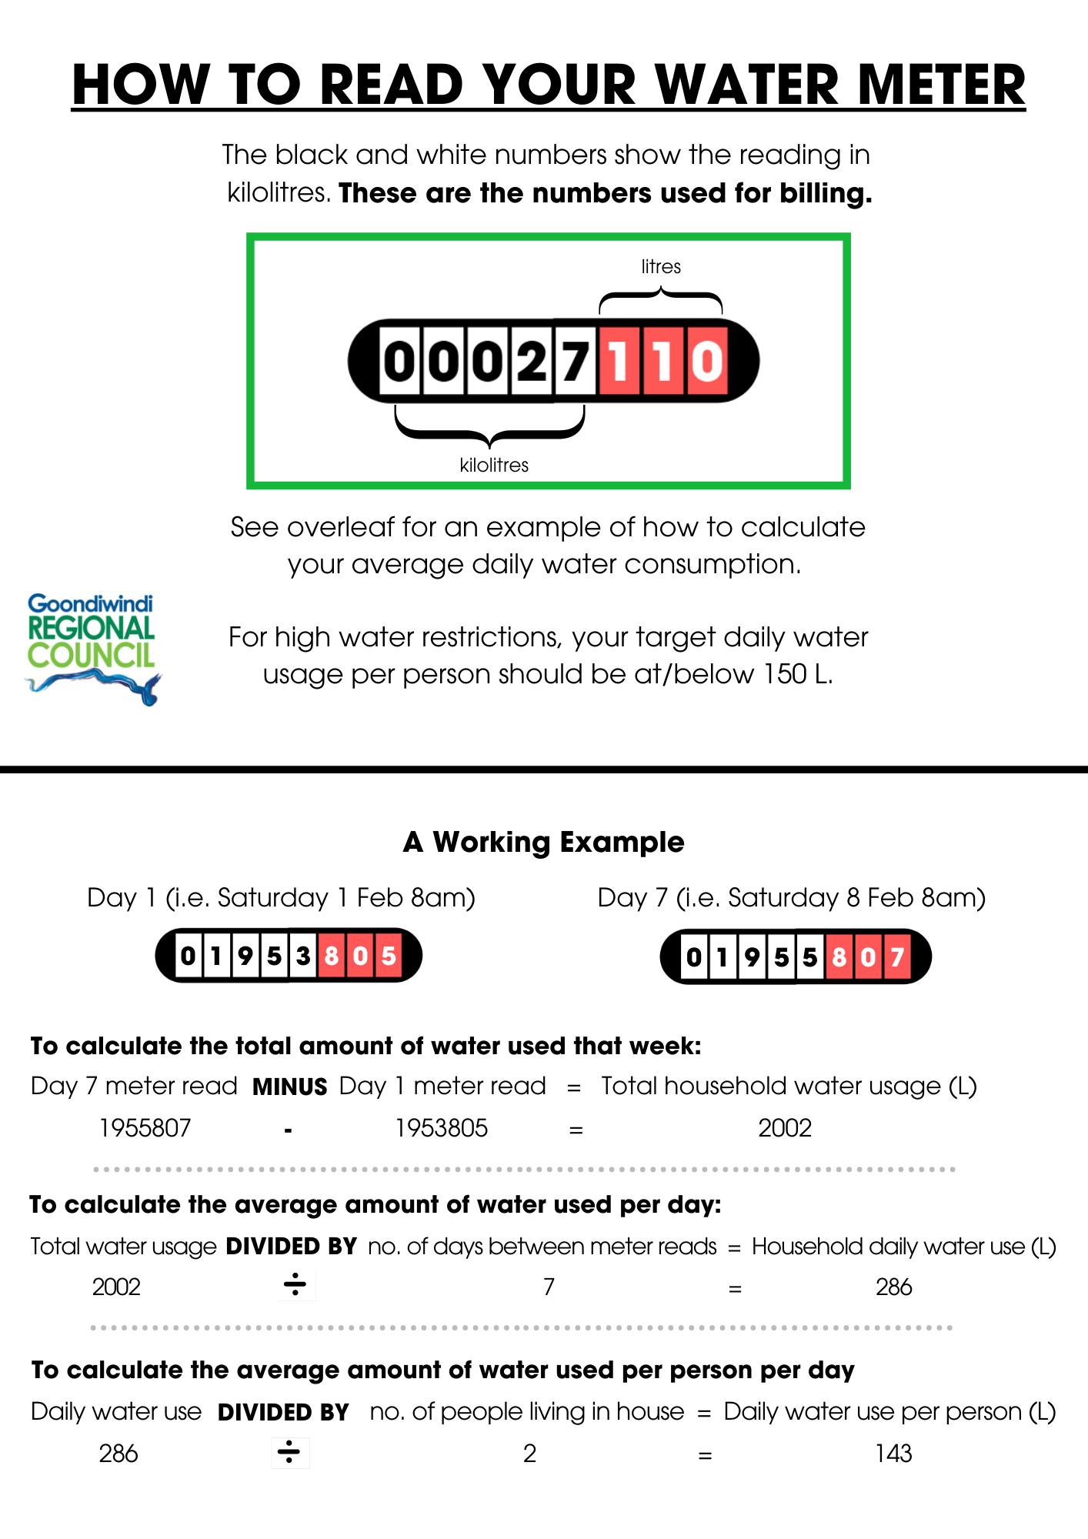
Week | Day 1 Meter Read | Day 7 Meter Read | Total amount of water used that week | Average amount of water used per day | Average amount of water used per person per day
EXAMPLE | 1953805 | 1955807 | 2002 | 286 | 143
1

2

3

4

5

6

7

8

9

10

11

12

13

14

15

Fill in your own table – example provided

